**CHAPTER 79 – UPDATE ON MY SIBLINGS & FAMILIES**

**SIBLINGS UPDATE:**

I am so blessed to have four wonderful brothers (3 are still living in 2017), and a wonderful, beautiful sister. I am so thankful for all of them and their special spouses and families. I am thankful for the wonderful memories of growing up with them, and growing old with them. I am thankful that we all love each other, our families and the Lord. We were all in the temple a short while before Kim & Jeanenne went on their 2nd mission. This time to Africa. I started crying in the Celestial room of the Ogden Temple as I stood there with all of them and their spouses, who I love very much also. I felt that dad and mom were there with us and proud of us that we are all trying to endure to the end so we can come home to our Heavenly parents and be with them (our earthly parents) eternally.

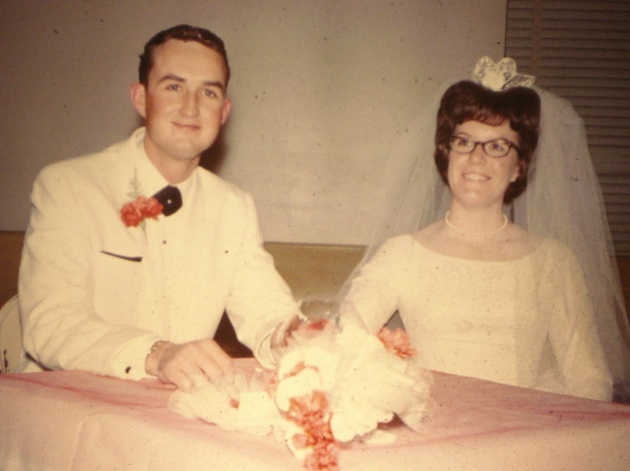**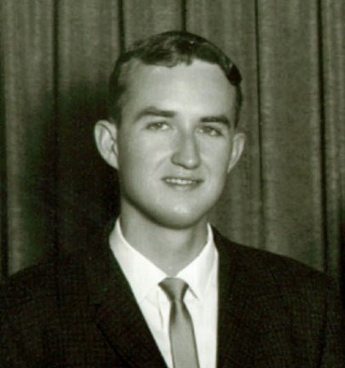HAL:** Hal passed away in 1975 at age 35. He took his life, due to his drug addiction (sleeping pills), but I still think of him, I love him and will be happy to see him again after this life. I don’t know where he will be, but I know he won’t be in Hell, and I know I will see him and hug him again. Ken and I had been living in Arizona and there was a recession so the building industry wasn’t going well, and Larry was just having his supervisors (Ken & Ron) dig him and Tammy a swimming pool just so he could keep them. We had been praying about what to do when John Howard, from Commercial Security Bank called Ken and asked him if he would be willing to come up and take over the night shift in the data processing department. We did and moved up and were able to move into Mom & Dad’s old home in Sunset, which they had been renting and it was available, so Mom asked if we would like to rent it. We did. I think this was an inspired move, by the Lord, as I needed to be here for Hal. He would call me and we would talk for an hour or more each time. When he would overdose on his sleeping pills and be in the hospital, I would go and visit him and we would talk. He told me that Jean didn’t love him. I tried to assure him that she did. I talked to Jean and she said she didn’t know how to show love, as her parents had never shown love to her. I couldn’t understand that, but maybe it was because my parents did show love to me and Ken and I show love and affection for each other and our children as well as our parents, relatives, friends and others. Jean finally took Cindi and left Hal, hoping to make him realize that he had to quit the pills or he would lose them. It didn’t work, it backfired and he took his life. Jean felt so bad and hoped we would forgive her, and we all did.

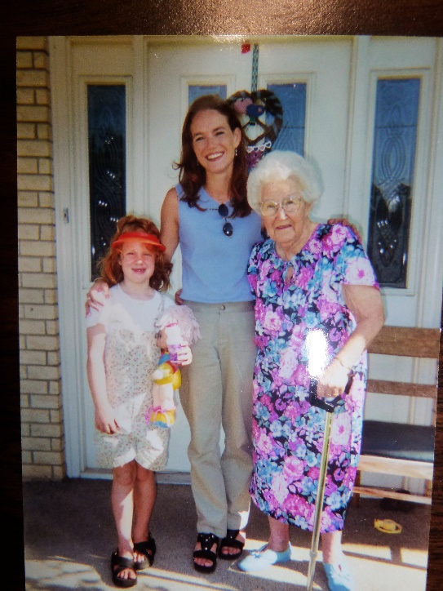 However, Jean also passed away a few years later, at a young age. She had health problems, but she was able to be with and love her daughter and granddaughter for a few years. Cindy had gotten pregnant with Samantha. Cindy had gotten on drugs as a teenager and Samantha brought her joy and happiness. However, the drugs wrecked her life. She lost Samantha because she could not overcome this addiction. She finally took her life, and that is so sad. I was notified by the police in Boulder Colorado, as they found my phone number on her phone. Ken and I left for Colorado, stayed with Samantha’s adoptive parents, Brian & Mercedes Dugan. We helped with funeral preparations and enjoyed being with Samantha and the Dugan’s, even though it was a sad time for all of us. She wanted to be cremated, so we took the urn with her ashes home. My siblings and their families and Ken, myself and our family held a memorial service for her and then we had her urn buried next to her parent’s graves in the Morgan Cemetery. Cindy did want her temple work done, so I was able to get it ready, get her endowment and have her sealed to her parents. Georgia was proxy for Cindy, I was proxy for Jean and Ken was proxy for Hal. We were happy to do that.

June 11,2019 Ken and I went to Chubbuck, Idaho to Terry & Angela’s home where they hosted our sibling and spouse get together. Kim read a letter which Jean had written to him years ago which talked of a near death experience where she saw Hal, her Mom, brother and a cousin who had passed away that day. She said she had cheated death four times, but it was just a few months later, that she did pass away.

**BRYCE, DEANNA & FAMILY**:

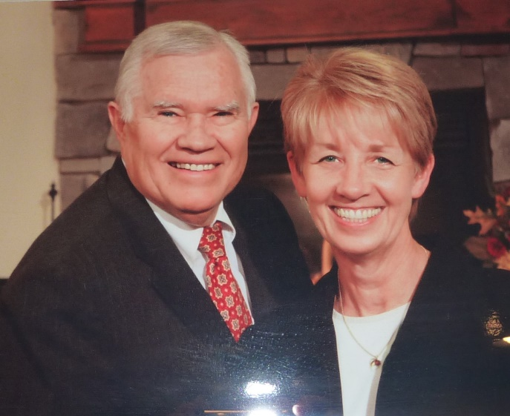Bryce and Deanna lived in Roy for a short time. I remember the one Christmas; Bryce had found a giant tumbleweed. He hung it from their ceiling, decorated it and that was there Christmas tree that year.

My brother, Bryce, is a character. You never know what he will say. Some of the things that come out of his mouth used to surprise me, but they don’t now. One time he was walking behind me and he said: “Mae, you have a butt just like our dad, you have a flat butt”. Another time I had bought some shoes and I loved them, but Bryce said: “Mae, where did you get those shoes, they look like clown shoes.” I don’t let it upset me, I just figure “Oh, that’s just Bryce.” It has been hard on Deanna and his kids at times, however. They love him to pieces, but he embarrasses them at times, especially when the kids were young. I remember Nolan telling us that one time, he had forgot to bring his gym clothes. He had called home and Bryce brought them to him, but he went into his class and said out loud: “Where is Nolan Porter, oh Nolan, here is your gym clothes.” (Anyway, I think it went something like that). Bryce is a great guy though; he would give the shirt off his back to you if he thought you needed it. Ken has borrowed tools, etc., from Bryce and Bryce will just say: “You keep it, you might need it later and I know where it is if I ever need it.” He is always so good to his neighbors and anyone who needs his help.

Bryce is stockier than the rest of us, and has a temper at times. He looks and acts somewhat like our Grandpa Bushnell. Mom used to tell him that he was her only Bushnell. The Porters were thin and the rest of us took after the Porters.

When Bryce got out of the military, he talked to Hal and Hal loved being a fireman so talked Bryce into becoming one, but Bryce was a fireman for the government. He worked at a plant way out from Grantsville, so he had a long way to drive, but he would work four days, I believe, and be off three (something like that). If they didn’t have a fire, most guys would sit around and play cards, play pool, etc., but Bryce would usually read.

Bryce & Deanna raised their five children in Clearfield. They are: Nolan, Shanna, Wendy, Chad and Darrin. They are all good kids. After Darrin got married and Bryce retired, Bryce & Deanna went on a mission. They were called to Spain. Bryce knew some Spanish from when he learned it on his mission, so he could speak some. He was called to be the Branch President in one of their towns. Their mission president was very strict, even with the couples, so they didn’t enjoy their mission like Ken & I did. When they returned, they sold their home in Clearfield and bought one in Willard. They wanted some remodeling done, so they asked Ken if he would do it and they would pay him. Ken did and it turned out nice. Bryce & Deanna’s daughter, Wendy, Nathan and their family live close by, so they have enjoyed that. Their children all married wonderful spouses and have special families.

Deanna got sick and the doctor found a large tumor in her liver. They had to put her on Chemo to shrink it and then they operated to take it out. That was in 2015. She recovered, but in 2017 they found two more. They were small, so they operated again in September? to remove them. This was a harder operation on her, she had such a hard time, but she is a fighter and did recover. She is doing much better now (December 2017). She was the Relief Society President in their ward and stayed in all during this time. She had good counselors and they would talk with Deanna on the phone or come to her home for presidency meetings and then they took over for her. Sometime later, as they tested Deanna, they found more tumors in her liver. They did chemo, but it didn’t help, so they did radiation and did it up through the groin. She has recovered and is doing well now. (2019) She lost her hair with the chemo treatments, but it came back in white the last time and is beautiful. Deanna has a cousin who is a beautician and has always done Deanna’s hair, so she looked beautiful even when her hair was coming back in. All my siblings and families prayed for Deanna throughout all this as we all love her. She has such a beautiful spirit. Bryce was a great support for Deanna and helped her so much, so we are proud of him. He loves her very much. Bryce has health problems also. He has COPD (lung problems) and takes thyroid medication.

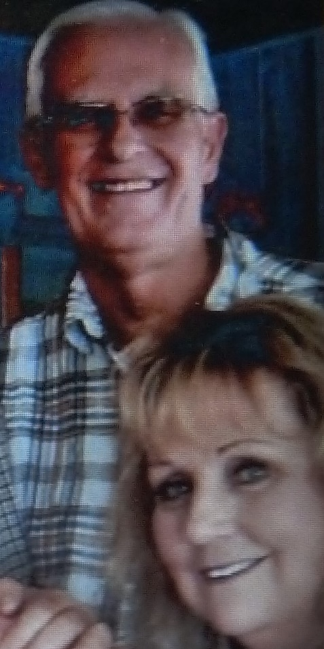**TERRY, ANGELA & FAMILY:**

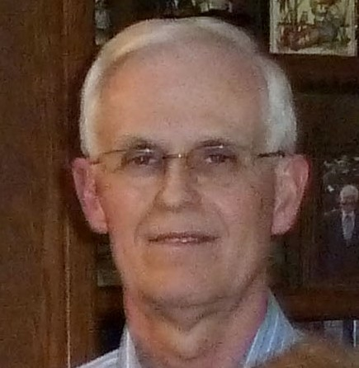Terry and Angela raised five children in Anchorage, Alaska - Brannon, David, Jabin, Maliah & Jaren. Finally, the dark and cold winters were too hard on Angela, so she talked Terry into moving down to Chubbuck, ID where their daughter, Maleah and family live. They waited until Angela retired from her school position. They moved down in August 2015, taking Jabin, their Down Syndrome son, with them. Jabin is happy living by Maleah and her family as they give him lots of love and attention.

Terry & Angela’s three sons, Brannon, David & Jaren and their families are still living in Alaska, so Terry & Angela still go up to visit these families, and Angela still goes up to tend their grandchildren when their sons go on vacation.

Ken and I did visit them in Alaska in 2006 and had a wonderful time. Angela wasn’t feeling the best, so she stayed home some days when Terry took Jabin, Ken & I and showed us some beautiful places. At night, Angela would have a wonderful meal ready for us and one evening she invited their married children and their families over for dinner and to visit with us. That was great. On Saturday, Angela, her daughters-in-law, and I went shopping at the swap meet. That was lots of fun. Ken and I went with Terry and Angela to the Anchorage Temple for an Endowment Session. That is a beautiful small temple and we were excited to go there. Another day we took a picnic lunch and went to the ocean. It was a bit chilly that day, but it was beautiful and we walked along the beach after we ate. Their Sons, David & Jaren took Ken fishing, and Ken was able to go on a chartered boat to catch halibut and salmon. Another day, Terry and Angela took us to a place (can’t remember where) to take a day cruse on the ocean. We saw all kinds of sea life, including whales & seals. The captain was a great tour guide. We played games until one in the morning and later as it didn’t get dark until late. Terry and Angela were great host and hostess and we had a wonderful vacation with them

We are happy that they are closer to us now and can attend our Sibling get togethers, and other family reunions and activities. Terry is our “tall” porter. He is 6’5” tall and he is still quite thin. He is usually really happy and fun to be around. Two of their sons have left the church, so that is a heartache for Terry & Angela. Their son, David, had problems with his dad and treated him very bad for several years. They are finally getting back together now and Terry is sure happy about that. Angela is a wonderful sister-in-law, and I love her.

**GEORGIA, RICK & FAMILY:**

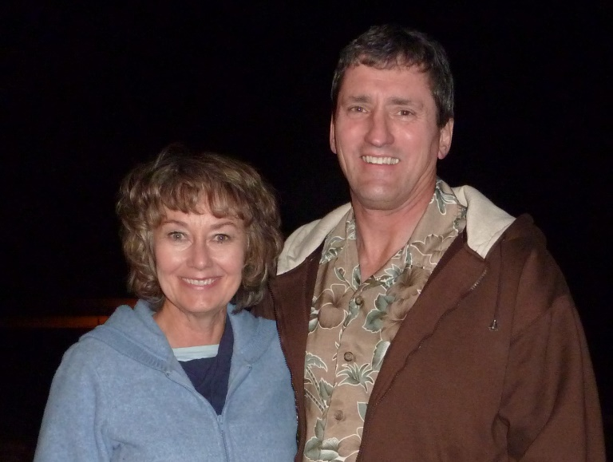Georgia had met Rick Tew, while Max Blair was on his mission, and they fell in love. She realized she didn’t want to marry Max so when he returned, she talked with him and he was okay. Georgia had dated several great young men, but Rick was the one she chose to marry. They were married in the Salt Lake Temple. I was living in Arizona, but flew up as Georgia had chosen me to be her maid of honor and Sandi and Shellie (Also Cindi) to be her flower girls. She chose pretty orange material for the dresses and white pinafores to go over them. I could sew as I had made Sandi, Shellie, myself and our sons some of our clothes, but we didn’t have much time, so Mom had asked Aunt Beth if she could help us. I was in Utah three weeks. I can’t remember whether I brought the children up with me or not, I probably did as Ken had to work. He must have been working for Hughes Air West Airlines as a computer programmer at the time, and it only cost us $4 to fly up & back. Ken flew up for the wedding. It was a beautiful wedding and wedding reception. Georgia first lived in an apartment in Ogden, while Rick went to college to become a seminary teacher. He has been a great seminary teacher and the students loved him. They moved to Clearfield for a while and then bought a home in Fruit Heights and later built a larger home just down the street from this first home. This is where they raised their family of five children: Bryan, Kristy, Brady, Nathan and Linsey. They are all good kids.

Georgia went to Weber College and took child development classes. She had part of their basement, in their new home, made into a pre-school and she taught pre-school until Rick retired from teaching. The children loved Georgia and she loved them. She was a great pre-school teacher and the parents kept putting their younger children in her school as they all thought she was great also. Her class was always full at the beginning of each year. She taught both three-year old children and four-year old children.

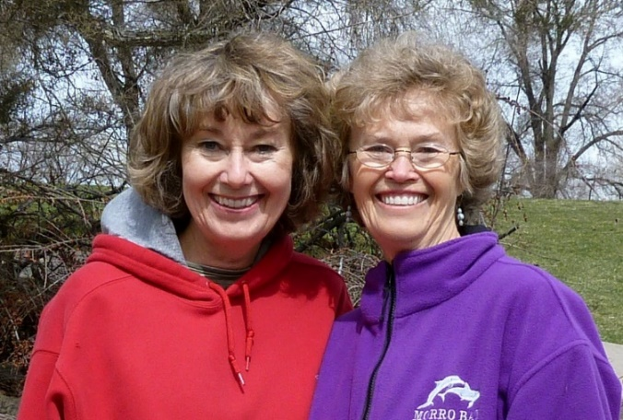When Ken and I moved back to Utah, Georgia and I would get together and either go walking and talking, or go to lunch together and have a good visit. We also talk on the phone for long periods of time to catch up on what each other is doing. When they owned a membership in “Camper World”, she invited me to go spend a couple of days with her in a cabin there, to have a “Girl’s Time”. We talked for hours, but also went on walks and enjoyed the beautiful scenery. I am very glad to have a sister. Brothers are great too, but sisters can talk about anything, at least her and I can. We really enjoy each other.

Georgia and Rick’s children all married well and have cute families, except Kristy and she had two husbands and both turned out to not be good husbands. She and her second husband, Dave, adopted a little boy who they named “Jack”. She finally divorced Dave as he was stepping out on her and not treating her good. Kristy’s health is bad with Fibromyalgia and she suffers terribly with it. Jack is her reason for living. She is a wonderful woman and we all pray for her.

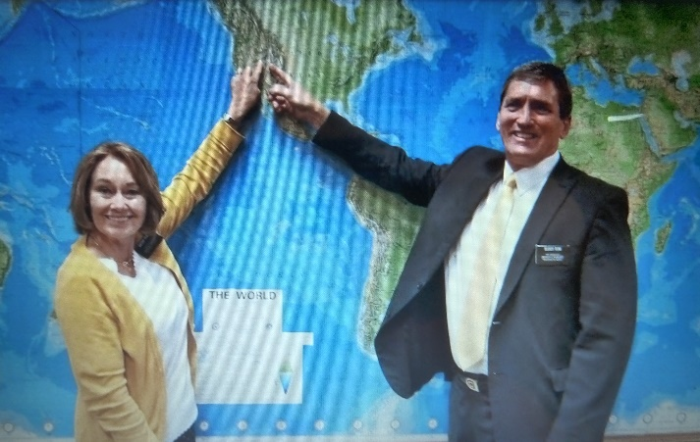

Georgia and Rick went on two missions, one to Grass Austria, which was a CES mission, and one to Salt Lake where they did proselyting, and had much success. Rick is so well versed in the scriptures and very confident in teaching and Georgia is vivacious and warm and they did well together. They were able to just live in their home for this mission and drive back and forth to Salt Lake. (2019)

Rich is a wonderful guy. He was a fabulous seminary teacher for 30 years and all his students loved him. He has been a Bishop for a young singles ward and they all loved him. Most everyone loves him. Ken and I do too, but he has a mental problem – a foiba which has caused Georgia untold misery over the years. It was finally diagnosed and was explained to her why he treats her this way. He loves her, but with this sickness, those who have this condition are good to everyone else except their spouses. Georgia and Rich have been to marriage counselors and Rick is doing much better now, but still not all the time. When Georgia & Rick went on their mission to Austria, after both of them retired, they were excited to go. I received emails from Georgia saying that her hands and head burned so bad that she could hardly stand it. She went to doctors and got medicine, etc., She wasn’t able to cook and since they were on a CES Mission where they had Family Home Evenings, activities, breakfasts and Dinners, one of her main responsibilities was to cook meals and refreshments. This she couldn’t do with her hands so bad. Another couple missionary had to take over for a while and Rick had to cook. Her hands finally got better, but her hair was coming out in brushfuls, she said, and her head burned and hurt to touch it. She realized it was from stress and much of it came from Rick as he was pressuring her to do more and be a better missionary. She was trying her best, but because of his problems, it was hard for her. Things got better when they got home.

They are on another mission now (2017) This mission is in their stake and a Salt Lake stake, so they live at home. I hope things will be better for both of them on this mission. It seems to be. They did have a wonderful mission and converted and baptized several people and they helped so many. They ended up not working in their stake, as the Liberty Stake in Salt Lake really needed them and so they were there almost every day. Many of those people live in shelters or low-cost apartments and are in poverty with different problems including word of wisdom problems. Rick is very compassionate and so was always giving them food, helping them get cars, appliances, etc. They were asked to extend as the bishops kept having people for them to teach. Georgia had told me of the beautiful chapels they held their meetings in, and said Ken and I should come down some time and they would show us these beautiful original buildings. We did one Saturday. We went to one of their baptisms and then they took us to these other buildings. We were awed at the beauty. Georgia & Rick reported their mission in their ward in February 2019. They gave excellent talks.

Their daughter, Kristy, has such terrible health problems and has had most of her life. She has also had two bad marriages, so Georgia & Rick try to help her as much as they can.

Georgia called me one day and as we were talking, she asked me how we were doing financially. I told her that I was thinking of seeing if I could get a job someplace, even at Walmart’s as we needed more money since Ken couldn’t drive a school bus any longer, since he had had that bout with vertigo. Georgia said: “No, you’re not. We have investments that will be paying off good soon, and we just got $80,000 from Rick’s father passing away, so we will send you some money each month.” I hated to have them do that, but I did really appreciate it. She sent $100 the first time, and then she said we got a raise and she started sending $200. Three months later she said we got another raise and she started sending $300. She said when they started getting the money back from their investments, she would raise it again. Rick agreed with her to do this. In December, she called and told me that the investment they had turned out to be a scam. Their son, Brady, has told them what a secure investment it was as I think the man, over the investment, was a good friend of Brady’s in-laws and they really trusted him and they invested a lot as also did Brady, Kristy and others of the family. She said they hadn’t told Kristy yet as she had quit her job expecting the money to start coming in soon and her job was very stressful and with her bad health, it was really hard on her. Brady was going to tell Kristy. But in the meantime, Georgia said they wouldn’t be able to afford to send me the money anymore as they would need to help Kristy out financially. I sure understood and thanked her again for the help they had given us. She asked if I wanted her to call and talk to David. She knows that David makes good money and that he could afford to help us now that they couldn’t. I told her “No”, that I would talk to him if I needed to, but for right now we were okay. Another time when we were at Georgia & Rick’s having dinner and playing games with them, Rick had mentioned that they do not pay tithing on their social security checks, as we have already paid tithing on it. He said they just paid tithing on their retirement checks. I had heard that before, but if Rick (who is so religious doesn’t pay tithing on it), then we shouldn’t have to either. Our bishop and friend, David Presnell said that our stake president didn’t feel that members had to pay tithing on social security, but it was their decision. David said he only pays half of theirs. Ken and I were at the “Old Folk’s Sociable” on Saturday, March 28, 2019 and while Ken was dancing with Chelci, Sandi said that Georgia had told her about them helping us with money and how they couldn’t any longer and that she was worried about us financially – so Sandi gave me $200. I didn’t want to take it, but she insisted saying she had the money to do it now, but maybe wouldn’t be able to later. Sandi said to keep it and when I needed it, it would be there. That was special of her. She said she hadn’t told her other siblings, and I was glad. I talked to Ken and we decided it would sure help our budget if we didn’t pay tithing on our social security, but only on my retirement and any other money we receive (like the $200, Sandi gave me). I sure hate to be a burden on our children, and I hope and pray we won’t be.

**KIM BYRON, JEANENNE & FAMILY:**

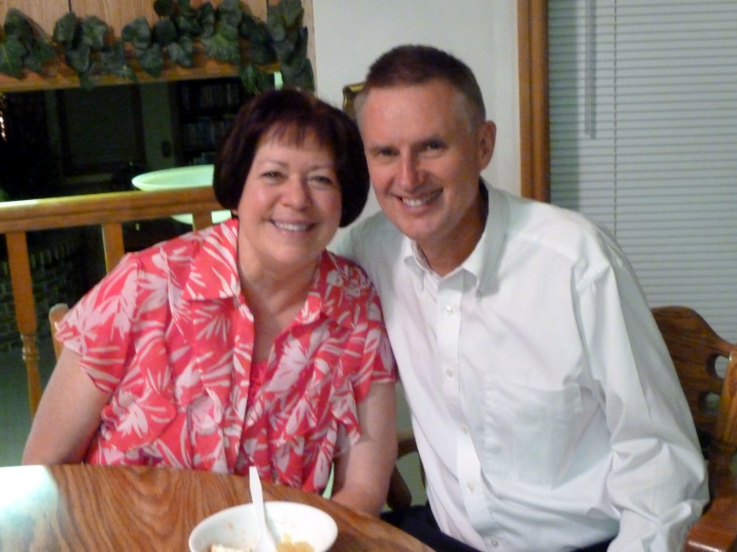Kim went on his mission to Holland and when he returned, his Bishop lined him up with Jeanenne. He knew both of them and knew they would make a good match. Jeanenne had gone on a mission also. Kim had dated a cute girl before his mission and thought she would wait for him, but many don’t wait as they meet other guys while the missionary is away.

Kim didn’t go to college, he became an insurance salesman for Beneficial Insurance. They had a struggle financially at first, but soon he had many clients and has done really well. They bought a home in Clinton, then moved to Brigham City and loved it there, but Kim had always wanted to live in Morgan where our roots are on the Porter side, so they were able to build a beautiful home there. It didn’t matter where Kim lived, since he could sell insurance anywhere in Utah. Now he can also sell in other states. Kim did so well that he won several trips. He took Jeanenne on some, and took some of their children for a graduation trip. He took Misha and Kaleesee to South America to Guatemala where they did service in helping to build a school house (Anyway, I think) They had a great experience, and saw what a third world country is like and the poverty there. It makes us very grateful for living in America.

They raised seven beautiful children: Charity, Dezeree, Summer, Joshua, Misha, Caleb and Kaleesee. Their children have married and Kim and Jeanenne have several beautiful grandchildren.

**Kim is a HIKER,** boy is he ever a hiker. He loves to hike. He can out hike about anyone. Our sons are hikers too, but when they went with Uncle Kim, they could hardly keep up with him. When we would go to the Morgan Cemetery to put flowers on our family graves, Kim would say: “Who wants to hike up to the “M” with me. He didn’t get many takers. I think Caleb is his only child who would go hiking with him at times. Kim would go hiking by himself many, many times. He said it was good for him and helped him think about his clients and how he could help them, so hiking helped his health and wellbeing as well as his business. I used to worry about him going alone for fear he might fall and hurt himself and no one would know. He carries his cell phone with him now that we have them, so I feel better about him going now.

Kim and Jeanenne are such a wonderful couple and so spiritual. They have raised 7 children, but have had lots of heartache too. Their oldest son, Joshua, came home from his mission, homosexual. He is married to a partner. They only have three out of their seven who are still active in the church – Charity, Summer and Caleb. The others are good kids, but misled. Deseree, their second child, has had two bad marriages and is now living with a man and they just had a baby. She was so excited to be a mother. I hear that her guy is a good man and treats her good and that they plan to get married, they probably already are. Charity, Summer, Mysha and Caleb are married and have cute families.

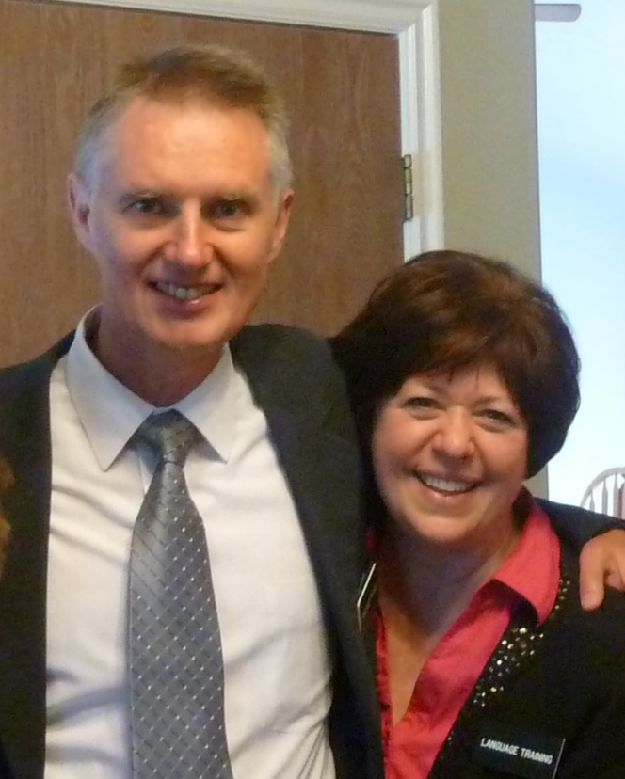Kim and Jeanenne went on two missions together. First, they went to Sr Lanka, which is an island just below India and just recently (November of 2016 to July of 2017) they returned from their 18-month mission to South Africa. Jeanenne has some health problems so Kim wanted to go while they were still young and as healthy as they were. He left his business with another agent both times and then came back to it. Kim was even able to go hiking on his missions.

Mysha and Johnny lost a baby a few years ago and haven’t been able to have any more since, until this year. They adopted a baby boy and then she gave birth to a son. Summer gave birth to a baby boy this year also. All these grandsons were born while Kim & Jeanenne were on their mission. I know this was hard for Jeanenne not to be there with her daughters and their new babies, but she will be blessed for her sacrifice. They were great missionaries and worked hard. They have strong testimonies and are great people. They reported their mission in their ward, and we were able to attend. Their talks were amazing, but they are amazing people. We sure love them.

**Sibling & Spouse Get-Togethers:**

We decided a few years ago to have a sibling and spouse get together once every three months, and to take turns hosting them at our homes. These have been great and have kept us in touch with each other. We have a great meal, visit and sometimes play games. The year that we were in charge of the Bushnell Reunion, we spend these get-togethers planning and preparing for this reunion. Bryce & Deanna have a time-share condo and they have invited us all to go up there and spend a couple of days which was really fun. We went to the temple together last year and that was wonderful. When one couple was on their mission, we would miss them, but still held them every three months. It was great when Terry and Angela moved down from Alaska and could be with us at these and other reunions and activities.

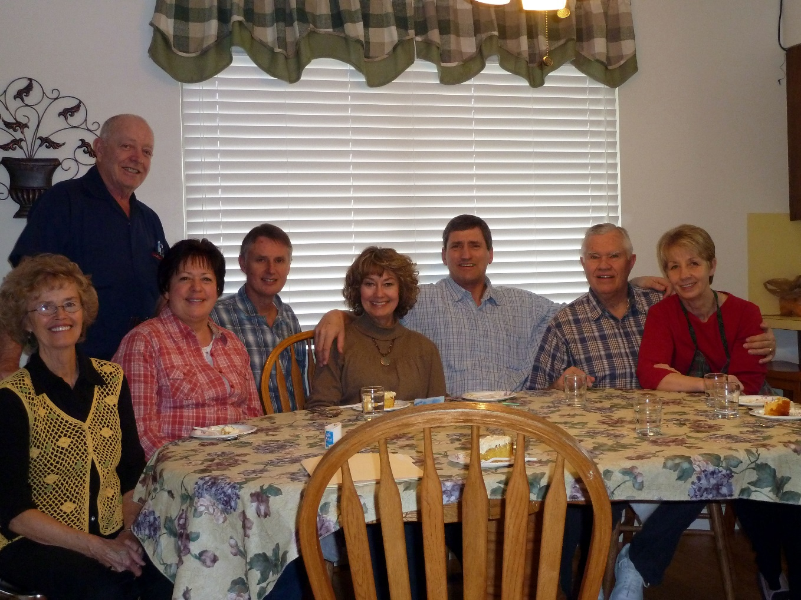

**(**The picture above was at Bryce & Deanna’s home. It was before Terry & Angela moved down from Alaska – left to right: Mae with Ken behind her, Jeanenne, Kim, Georgia, Rick, Bryce & Deanna).

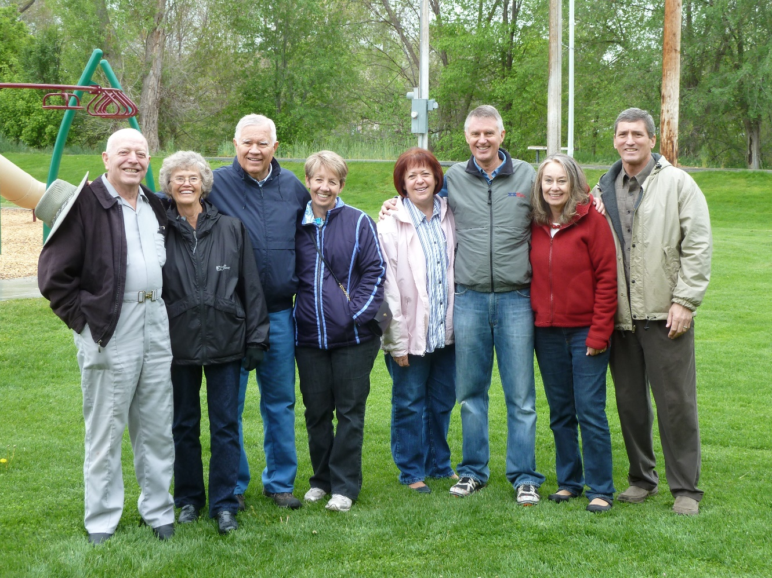

What a great husband, great siblings, sisters-in-law and brother-in-law I have.

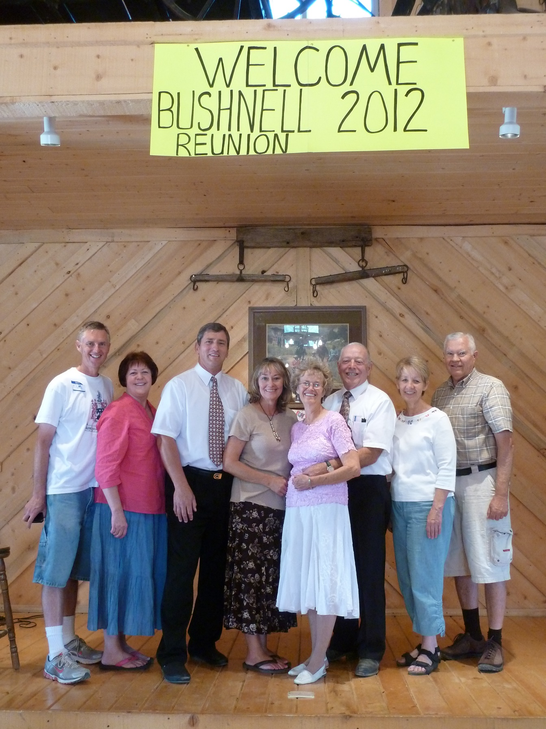

Me, Ken and my siblings and their spouses put on the Bushnell Reunion in 2012 at Keela & Pete’s barn in Tropic, Utah. It was a lot of hard work planning and preparing for it, but everyone enjoyed it and had a lot of fun, so it was a success and worth all the work.

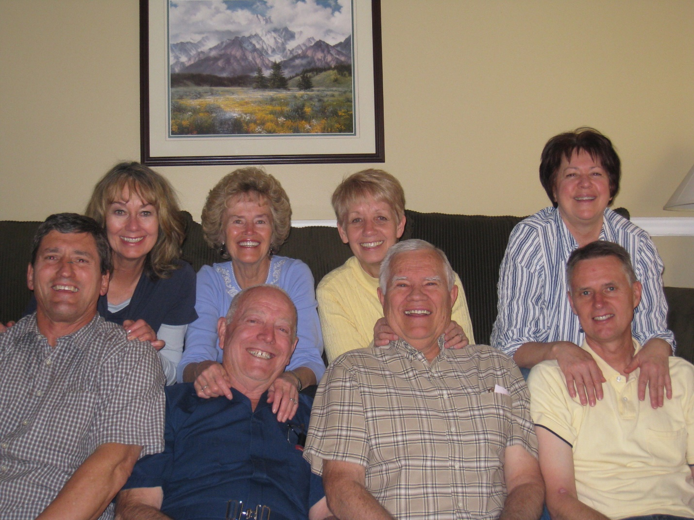

All my living siblings and their spouses are active in the church and have strong testimonies, and I am thankful for that. We have such fun being together. I love them all very much. We have missed having Terry & Angela with us for many years, but they finally moved from Anchorage, Alaska to Idaho, so we can see them and have them join us for all our extended family activities, including these get-togethers.

**SIBLING & SPOUSE GET-TOGETHERS**: Ken and I get together with my siblings and spouses every three months, and it is fun to now have all five of us together. We take turns hosting this get-together. Before Terry & Angela moved down and when Ken and I, Bryce & Deanna, Georgia & Rick and Kim & Jeanenne went on our missions, we still tried to get together with whoever was around. It is now 2019 and we all got together at Kim & Jeanenne’s as they had just returned from their mission to South Africa. It was fun all being together. After dinner, Kim suggested that we go into their living room or family room and sit around and reminisce about our parents, Hal and growing up together. He also suggested we tell about what we are doing now and about our missions. This was very enjoyable; I have such wonderful siblings and their spouses. When I was talking with our daughter, Shellie, recently, I told her about us doing this and she said: “I wish I could have been a fly on the wall, to hear all that.”

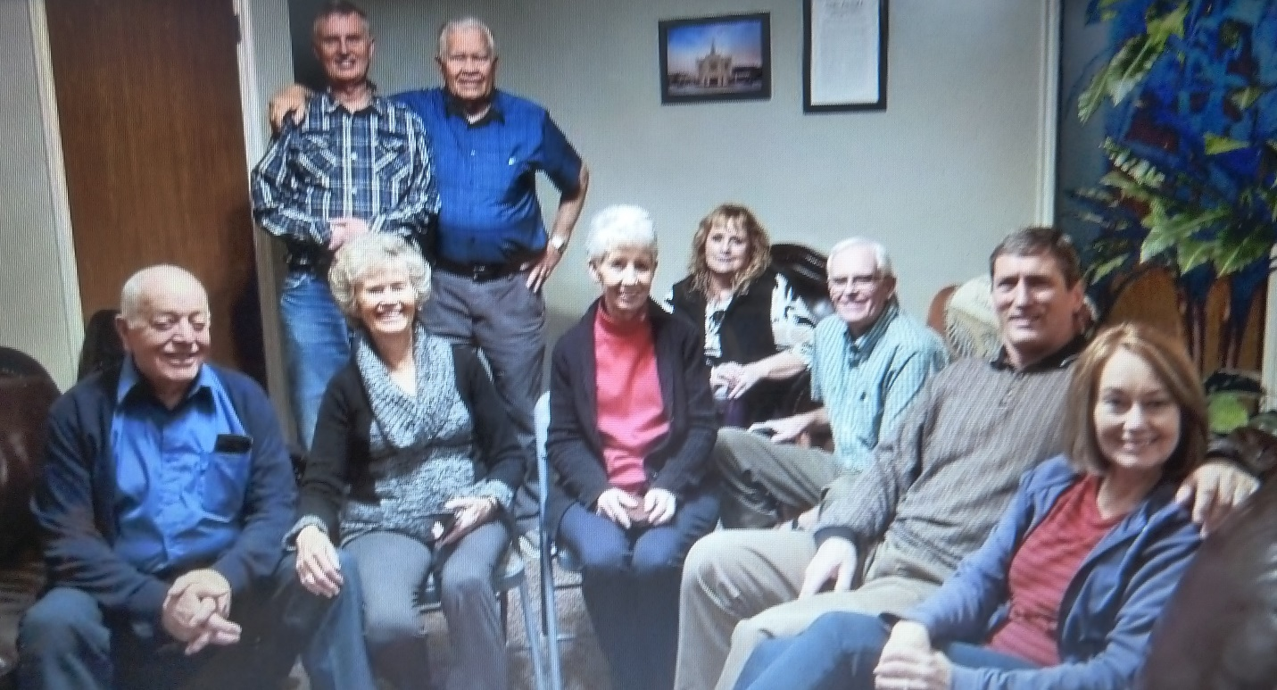

Yea! We are all together now that Terry & Angela moved back. This was taken in January 2019. Jeanenne took this picture, so wasn’t in the picture, darn.

June 11,2019, Ken and I went to Chubbuck, Idaho to Terry & Angela’s home where they hosted our sibling and spouse get together. We all met at 1 pm, ate a wonderful lunch which Angela had prepared (Chicken breasts cooked in a lime sauce, yams, green salad & rolls. She made a delicious dessert and they bought frozen yogurt for Ken. We visited, Kim read a letter which Jean had written to him years ago which talked of a near death experience where she saw Hal, her Mom, brother and a cousin who had passed away that day. She said she had cheated death four times, but it was just a few months later, that she did pass away. I have been working on compiling our dad’s history, pictures, documents, etc., and put all this information on a flash drive for each of my siblings. I gave it to each of them this day and also gave them pictures of Grandpa and Grandma Porter, at all stages of their lives. We had such a good time visiting, playing games and just being together. Angela had bought lots of snacks for us to eat while we played games. Bryce, Deanna, Kim & Jeanenne left about five that evening and Georgia, Rick, Ken & I stayed the night. We played “Panjandrum” and then visited until almost midnight. The next morning, we ate cereal, muffins, juice and fruit. Then we visited again until Ken and I needed to leave as we were going on to Idaho Falls to visit JaNae, Brad and their children.